**Session-18 Assignment**

**Name:-** Aryan Dilipbhai Langhanoja

**Enroll No:-** 92200133030

**AIM**: To understand basics of operational amplifier (OPAMP).

**Objective:**

1. To understand block diagram, pin diagram, symbol and working of operational amplifiers.
2. To become familiar with nomenclature used with OPAMP and OPAMP parameters and equivalent circuit.
3. To understand various open loop configurations like non-inverting, inverting and differential configuration.
4. To understand voltage transfer curve (VTC).

**Apparatus:**

1. DC power Supply
2. OPAMP uA741.
3. Resistor (1kohm)

**Task-1- Define the following OPAMP Parameters**

1. **Input Resistance -**

* For an ideal op-amp, the input impedance Ri is infinite, so, we can say that the input resistance of op-amp is very high.

1. **Output Resistance -**

* The output impedance of an ideal op amp is 0. This means that regardless of the amount of current drawn by an external load, the output voltage of the op amp remains unaffected. That is, no loading occurs.

1. **Output Offset Voltage –**

* Output offset voltage (Voo)- It is the output voltage of op-amp when both inputs are zero. Output offset voltage is due to dissimilarities in transistor and due to mismatch in Resistor values in the internal circuit of the op-amp.

1. **Input Offset Voltage -**

* The input offset voltage (VOS) is defined as the voltage that must be applied between the two input terminals of the op amp to obtain zero volts at the output.

1. **Input Bias Current –**

* The input bias current parameter, IIB, is defined as the average of the currents into the two input terminals with the output at a specified level. It is expressed in units of amperes. The input circuitry of all op amps requires a certain amount of bias current for proper operation.

1. **Input Offset Current –**

* The input offset current, IOS, is the difference between IB– and IB+, or IOS = IB+ - IB–. Note also that IOS is only meaningful where the two individual bias currents are fundamentally reasonably well-matched, to begin with. This is true for most voltage feedback (VFB) op amps.

1. **Common Mode Rejection Ratio –**

* The op amp common-mode rejection ratio (CMRR) is the ratio of the common-mode gain to differential-mode gainSlew Rate.

1. **Slew Rate -**

* Explain the PSRR (Power Supply Rejection Ratio) for opamps. PSRR is the ratio of the change in input offset voltage with respect to the change in power supply voltage. The standard used in the datasheet is DC Variation. PSRR=20log(Power Supply Variation)/(Input Offset Voltage Variation)[dB].

1. **PSRR –**

* It is defined as the absolute value of the ratio of the change in supply voltages to the resulting change in input offset voltage.

**Task-2- Voltage Transfer Characteristics of OPAMP(Just draw and briefly explain meaning)**

**Characteristic:**

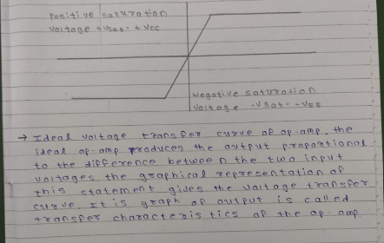

**Task-3: Open loop Non-inverting amplifier OPAMP Configuration**

**Circuit diagram:**

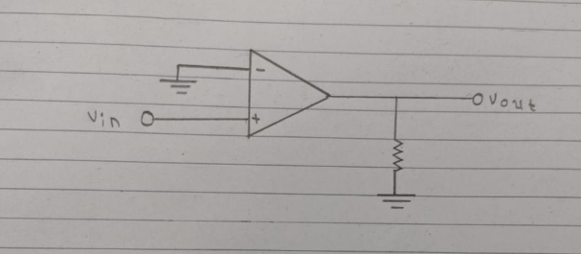

**Task-4: Open loop Inverting amplifier OPAMP Configuration**

**Circuit diagram:**

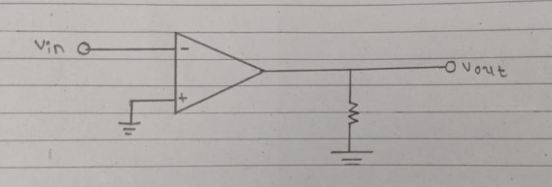

**Task-5: Open loop Differential amplifier OPAMP Configuration**

**Circuit diagram:**

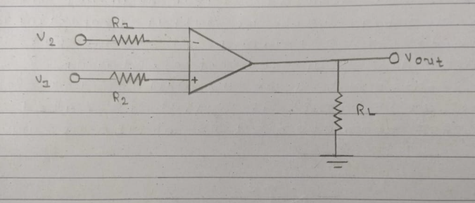

**Task-6: Equations for Open loop OPAMP Configuration**

Output Voltage:

Inverting configuration: Voutput = -A(Vinput)

Non-inverting Configuration: Voutput = A(Vinput)

Differential Configuration: - Vout = A(Vnon-inverting –Vinverting)

**Conclusion:**